**Hybrid Inheritance**

In simple terms you can say that Hybrid inheritance is a combination of **Single** and **Multiple inheritance.** A typical flow diagram would look like below. A hybrid inheritance can be achieved in the java in a same way as multiple inheritance can be!! Using interfaces

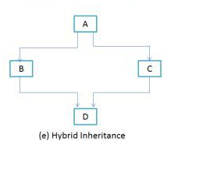

interface A

{

public void methodA();

}

interface B extends A

{

public void methodB();

}

interface C extends A

{

public void methodC();

}

class D implements B, C

{

public void methodA()

{

System.out.println("MethodA");

}

public void methodB()

{

System.out.println("MethodB");

}

public void methodC()

{

System.out.println("MethodC");

}

public static void main(String args[])

{

D obj1= new D();

obj1.methodA();

obj1.methodB();

obj1.methodC();

}

}

**Output**

MethodA

MethodB

MethodC